Literature Review of:
Palladium-Catalyzed Decarboxylative Ortho-Acylation of Tertiary Benzamides with Arylglyoxylic Acids
Joydev K. Laha,* Ketul V. Patel, and Sheetal Sharma

Mason Swanton
T00246877
CHEM 4420
April 9th, 2026

Introduction
This paper, written by Joydev, Ketul, and Sheetal discussed a palladium catalyzed ortho-acylation of tertiary benzamides using arylglyoxylic acids. How the type of palladium catalyst, additive (if any), oxidant, and solvent affected the yield of the product was recorded. Furthermore, the mechanism of this reaction was compared to previously reported insertion of palladium between the N-C bond of N-C=O
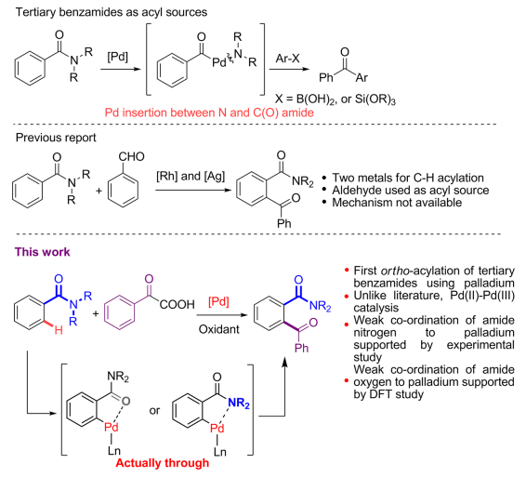
Figure 1. Comparison of previous reaction schemes compared to this paper's scheme

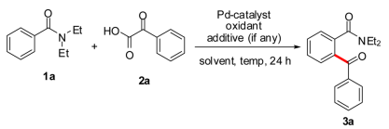
Figure 2. Reaction undergoing optimization study

Table 1. Varying reaction conditions for figure 2 reaction
Entry | Catalyst | Additive (equiv) | Oxidant | Solvent | Yield
1 | Pd(OAc)₂ |  | K₂S₂O₈ | MeCN | 00
2 | Pd(OAc)₂ |  | K₂S₂O₈ | DCE | 41
3 | Pd(TFA)₂ |  | K₂S₂O₈ | DCE | 47
4 | Pd(TFA)₂ |  | (NH₄)₂S₂O₈ | DCE | 83
5^{c} | Pd(TFA)₂ |  | (NH₄)₂S₂O₈ | Other solvents | Trace
6 | Pd(TFA)₂ |  | Ag₂CO₃ | DCE | 42
7 |  |  | (NH₄)₂S₂O₈ | DCE | 0
8 | Pd(TFA)₂ | TfOH (0.2) | (NH₄)₂S₂O₈ | DCE | 84
9 | Pd(TFA)₂ | TfOH (0.2) | (NH₄)₂S₂O₈ | DCE | 76
10 | Pd(TFA)₂ | PivOH (0.2) | (NH₄)₂S₂O₈ | DCE | 71
11 | Pd(TFA)₂ | K₂CO₃ (1) | (NH₄)₂S₂O₈ | DCE | 48
12 | Pd(TFA)₂ | TEMPO (10) | (NH₄)₂S₂O₈ | DCE | 0
^{c}Solvents such as diglyme, THF, dioxane, toluene, or DMF

First, this experiment tested how varying the parameters of the reaction would affect the outcome of the product. The yield of 12 different variations was documented, with the best yield (83%) in the presence of 10 mol % Pd(TFA)₂ (Note: 10 mol % means 10 mols of catalyst per 100 moles of our limiting reagent which is 1a). Pd(TFA)2 performed better than Pd(OAc)2 possibly due to the electron withdrawing effect of TFA making the Pd much more electrophilic. 3 equiv of (NH₄)₂S₂O₈ in 1,2-dichloroethane (DCE) at 80°C for 24hrs. Attempting further optimization using other solvents (entry 5) proved ineffective, however, the addition of an organic acid seemed to have a slight effect (entry 8). Entry 12 was used to help support the idea of a radical intermediate as 2,2,6,6-tetramethylpiperidin-1-oxyl (TEMPO) is a radical inhibitor.

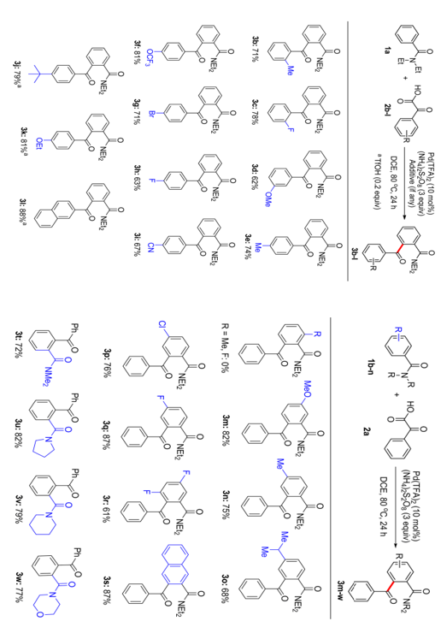
Figure 3. Yields of various arylglyoxylic acids (left) and various tertiary benzamides (right)
Above in figure 3, the various products and yields of arylglyoxylic acids synthesized from ortho-acylation of 1a under the optimized conditions from table 1. While meta and para positions had no problems reacting under the optimized conditions, tertiary benzamides that were ortho-substituted did not react with phenylglyoxylic acid 2a due to steric (methyl group) or electronic (fluoro group) effects. Finally, a noteworthy sterically unhindered regioisomer, 3m, was produced by 1d (a meta substituted tertiary benzamide). This unhindered regioselectivity means it only went to the ortho position that was furthest from the MeO instead of in between the amide and MeO. This gives a viable method for synthesis of regioselective products needed in other applications.
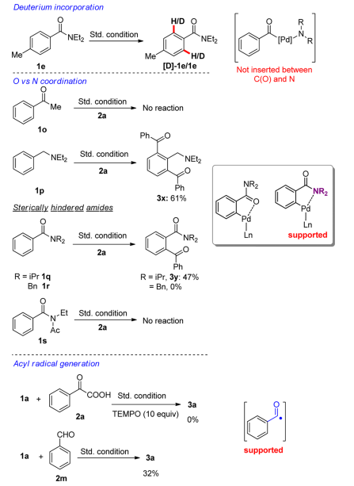
Figure 4. Control experiments
Above we can see the control experiments used to help identify the possible pathway of these acylations. 1e going to 1e/[D]-1e in a 7:3 mixture proved, through D₂O exchange, that the ortho position was where palladation could occur and that it was reversible. Next, coordination with oxygen vs nitrogen was tested using groups that excluded one of the elements. With no nitrogen present, 1o was found to not react with 2a, thus confirming the nitrogen group coordinated with palladium. This seems to have a similar effect in our experiment, where our added nitrogen group may help coordinate the attachment of t-BuLi to the ortho methyl group. Additionally, when the oxygen was not present, only the nitrogen group (1p), we can see addition of the acyl group at both ortho positions. This leads to confirmation that the amide group locks the conformation of the structure and leads to acylation on the ortho position nearest to the nitrogen group. This also could have relation to our laboratory experiment wherein the amide group directs the addition to the lateral ortho-methyl group through not only the nitrogen, but also through the conformational locking due to the amide. Steric hindrance was observed to have an effect as well as seen in 1q and 1r. 1s seemed to reduce coordination possibilities with the nitrogen as the acetyl group reduced electron density. Finally, since TEMPO was able to inhibit the reaction, it was suggested that a radical must be present in the intermediate. Testing with an alternate acyl source, 2m, yielded 3a which was then isolated thus suggesting a radical formation in the reaction.
With all of this in mind, the proposed synthesis mechanism was as follows:
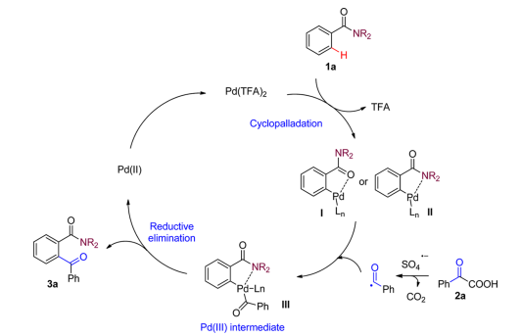
Figure 5. Proposed Mechanism

Reference(s)
- Laha, J. K.; Patel, K. V.; Sharma, S. Palladium-Catalyzed Decarboxylative Ortho-Acylation of Tertiary Benzamides with Arylglyoxylic Acids. ACS Omega 2017, 2 (7), 3806–3815. https://doi.org/10.1021/acsomega.7b00717

‌

