Chem 4480

Developing a Light-Activated Organic Polymerization ​Laboratory Activity with Applications to Dentistry​

By: Mason Swanton
Supervisor: Dr. Bruno Cinel
Co-Supervisor: Dr. Jess Allingham

Date: September 2023 - April 2024

Abstract
The focus of this directed study was to take three different Dimethacrylates (DMAs) and combine them with a photo-initiator, co-initiator, and filler in an attempt to make a similar product to what is used in dental fillings. The DMAs used were Triethylene glycol-DMA, Urethane-DMA, and Dodecanediol-DMA. These DMAs were used in tandem with camphorquinone (CQ) as a photo-initiator and Dimethylamino ethyl methacrylate (DMA-EMA) as a co-initiator. Silica gel, 200-400 mesh, was used as a filler. The results and information gained from these trials will then be used as a guide to setup a second-year organic laboratory that investigates polymerization reactions and the effect light has on specific reactions.

Introduction
The application of dental fillings is a very common procedure with around 90% of UK and American people having dental decay or fillings.^{1,2} Previously known to be silver fillings, the most popular fillings today are polymer derivatives made from methyl acrylate. Methyl acrylate is used in conjunction with a few other different monomers to make Glycidyl methylacrylate (GMA) or Dimethylacrylates or DMAs. The most used methylacrylates in dental fillings are Bisphenol A-glycidyl methylacrylate (Bis-GMA) Triethylglycerol-DMA (TEG-DMA). This experiment will analyze TEG-DMA as well as Urethane-DMA (UDMA) and Dodecanediol-DMA (D₃MA). These chemicals are used in conjunction with a co-initiator, photo-initiator, and filler to make a larger polymer found in many dental fillings.
Figure 1. Examples of monomer building blocks of dental polymers.

Polymers are a huge part of our everyday lives. From clothes, to plastics, to glues, the use of polymers has greatly impacted human lives. Polymers are made up of many monomers. An example of this is polyethylene, a polymer made up of ethylene monomers. Some polymers, like polyethylene can also have filling material in between two long chains as shown in Figure 2: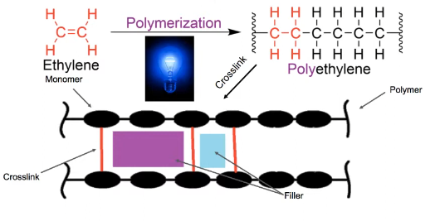
Figure 2. Polymerization reaction and polymer crosslink.³
In this experiment, different Dimethylacrylate derivatives, or DMAs, will be used in combination with camphorquinone (CQ) and dimethylaminoethyl methacrylate (DMAEMA) to make different polymers. The main polymerization reaction observed in this project will be a light-activated polymerization reaction involving radicals.
This experiment follows a similar radical reaction mechanism that is shown in Figure 3:
Figure 3. Radical reaction mechanism for polymerization.
There are very few literature articles reported on the topic of dental polymers and radical reactions and their properties. Moreover, at the time of writing this, there were no undergraduate lab experiments reported or procedures for this sort of reaction besides an online video³ found regarding Dr. Wentzel’s research into this topic. This area was intriguing to dive into further, and attempt to build a lab around, due to it holding many valuable learning aspects from first-year chemistry and second-year organic chemistry.
In first-year general chemistry courses, students learn about wavelengths and how they can affect reactions. The point is further shown in this experiment in that, while the reaction may cure over time in ambient light, it cures far better and faster using the proper wavelength of around 400-500 nm. Additionally, second year topics like radicals are introduced to illustrate reaction mechanisms and highlight stability of different radicals. Radical reactions follow three main steps: Initiation, Propagation, and Termination as seen in Figure 4.
Initiation:

Propagation:
OR

Termination:

OR
OR
Figure 4. Radical reaction mechanism and steps.

Project Background
The first part of this project required an understanding of what dental fillings are made up of as well as what chemicals would need to be purchased and how would they need to be mixed. Using connections with an in-town dental office, products used for fillings were identified and their MSDS sheets were investigated. After some investigating, it was found that each type of filling (flow, composite, or dual-cure) had a common element: some sort of dimethacrylate (DMA) with an interchangeable bridge between the methacrylate monomers (see Figure 5 and Figure 6 below).
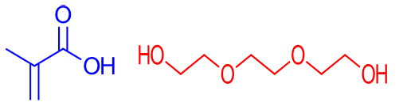
Figure 5. Methacrylate monomer (left) and an example of one of the interchangeable bridge options, Triethylene glycol (TEG) (right).

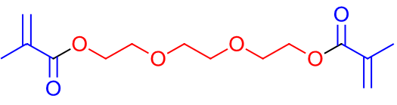
Figure 6. TEG-DMA molecule with the individual components coloured.
Once the components were identified, the next step was solving how to form the polymer chains. This is where the bulk of the research was done and where most articles came from that helped to structure the procedure. The most impactful discovery, though, was a YouTube video by Dr. Michael Wentzel.³ In this video, a detailed reaction scheme was depicted, showing how a photo-initiator (camphorquinone) alongside a co-initiator (2-(dimethylamino)ethyl methacrylate or DMA-EMA) was used to initiate a light-activated radical reaction forming the polymer chains and crosslinks. Along with Dr. Wentzel’s video, some other research papers were used to develop a rough idea for a procedure regarding the mixture amounts of our DMA, CQ, and DMA-EMA.^{4,5}
Before testing the procedure, a method to cure the mixture needed to be made to see if the polymers would be formed. Thankfully, a physics professor at TRU, Dr. Mark Paetkau, had multiple types of lights, ranging from UV to more blue light, that he was willing to lend (see Figure 7 below for the light used).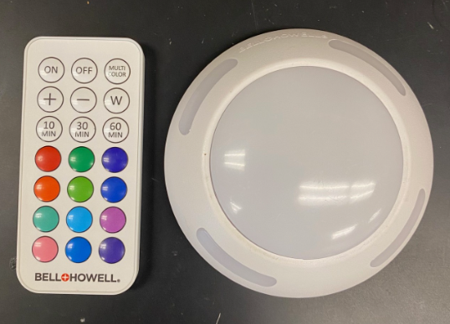
Figure 7. Light used for curing and observing the different effects of blue and red light.

Experimental
The procedure developed for this lab used two articles as a base^{4,5} alongside multiple trials to identify the mixture that most resembled the consistency and properties of dental filling material.

Procedure 1

- Put on PPE and bring chemicals to analytical balance
- Carefully weigh out 1.0000 g of the given TEG-DMA into 10 mL beaker
- Weigh out 10.00 mg or 1.0% weight of DMA by weight of CQ into separate 10 mL beaker
- In the same beaker as the CQ, weigh out 2.0% DMAEMA or 20.00 mg
  - The co-initiator should be in a 2:1 ratio with photo-initiator
- Mix the CQ and DMA-EMA thoroughly or until homogeneous
  - Note that some clumps may be seen, but these should dissolve
- Weigh out around 45% by weight filler (0.4500 g)
- Add the CQ and DMAEMA mixture to the DMA beaker and stir with stir rod until mixed well
- Once CQ and DMAEMA are added and mixed to the DMA beaker, add 0.4500 g filler of silica gel 200-400 mesh
Part 2
- After adding filler (optional) and mixing thoroughly, pour the mixture onto a small weigh boat
  - Keep majority of the mixture in one corner to create some depth
- Carefully place weigh boat, with mixture, into the center of the cork circle (keeping it at an angle as in Figure 4)
- Cover the cork with the light and begin to cure on either blue (~450 nm) or red (~650 nm) light for around 5 minutes

Varying Filler
Initial tests of this experiment were to identify the changes caused by varying the amount of filler used. To do this, a baseline mixture was needed for all other parts. The DMA used for these trials was TEG-DMA each time.

Table 1. Tabulated composition of filler, co-initiator, and photo-initiator for each trial.
 | Filler (%w/w) | DMA-EMA (mg) | CQ (mg)
Trial 1 | ~ 45% | ~ 20.0 | ~ 10.0
Trial 2 | 0% | ~ 20.0 | ~ 10.0
Trial 3 | ~ 70% | ~ 20.0 | ~ 10.0

Changing Photo-Initiator and Co-Initiator Ratio
Another one of the aspects to be examined was the ratio between the photo-initiator CQ and the co-initiator DMA-EMA. Originally, and primarily, a 2:1 ratio was followed for co-initiator:photo-initiator.⁵ This was then changed to a 1:2 ratio of co-initiator:photo-initiator to see the effects.

Table 2. Tabulated data of Trial 4 and 5 changing the ration of initiators.
 | Filler (%w/w) | DMA-EMA (mg) | CQ (mg)
Trial 4 | ~ 45% | ~ 20.0 | ~ 10.0
Trial 5 | ~ 45% | ~ 10.0 | ~ 20.0

Light Specificity
One quick trial that was run during the experiment was to prove the reaction was activated specifically with blue light. To do this, two batches were made according to procedure 1 and then for 5 minutes, one was cured under blue light, while the other was cured under red light.

Other DMAs
While TEG-DMA was used as the primary DMA throughout the trials, UDMA was also tested. The UDMA test consisted of following the same procedure and steps for TEG-DMA, however, no filler was used and no variations were done.

Learning Outcomes
Upon completion of this experiment, the following learning outcomes should be met:
- Demonstrate proper use of Personal Protection Equipment (PPE) and safe handling of chemicals​.
- Calculate stoichiometric amounts needed for reactions​.
- Use analytical balances to accurately weigh out reagents​.
- Investigate the effects of different wavelengths on a light activated reaction​.
- Gain experience using FTIR instruments and interpreting spectra​.

Results
After multiple trials, the best mixture made, based on consistency and properties after curing under blue light, was using 1.000 g TEG-DMA with 0.0100 g CQ (1.0% w/w) and 0.0200 g DMA-EMA (2.0% w/w) along with 0.4500 g (45% w/w) of silica gel 200-400 mesh based on the amount of TEG-DMA used.

Filler
Using the original composition amounts outlined in procedure 1, three batches of TEG-DMA, CQ, and DMA-EMA were made with no filler, 45% w/w filler (based on weight of TEG-DMA used), and 70% filler according to a literature reference.⁴ While the article used as reference for the procedure did use 70% filler, it was found that, for our experiment and materials, 70% filler was too much. When 70% weight of silica gel was added, the mixture became too gritty and sand-like and created small clumps. Upon curing this trial, it went from yellow clumps of a soft, sand like, mixture to hard and brittle clumps that were more white-coloured than any other mixture tested. This is most likely due to the excess of filler used causing it to wash out the yellow colour.
The mixture made with no filler was as expected. This mixture had the same yellow colour as the rest and was far less viscous. The main point of interest for this mixture is that, when curing, it was found to be slightly more oily than the others. Even when hard after curing, the top of the mixture would appear to be oily with a slight sticky or tacky feeling. This was addressed when subjected to longer cure times.
The last mixture composition tested was 45% filler added. This amount was closest to the desired consistency and properties. It remained slightly tacky and sticky before curing, while also being viscous enough to hold its shape. After curing, it remained hard and durable to when force was applied unlike the other two trials.
Overall, varying filler resulted in vastly different mixture as pictured in Figure 8 below.
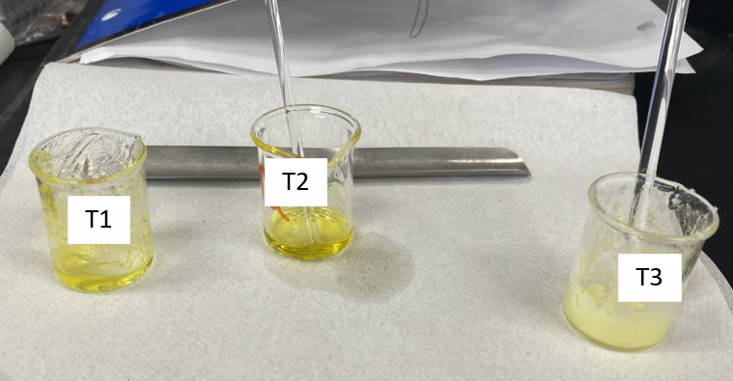
Figure 8. Visual of the three different trial mixtures with varying filler amounts (1 - 45%w/w, 2 - 0%w/w, 3 - 70%w/w).

Photo-initiator and Co-initiator Ratio
This ratio of 1:2 of CQ:DMA-EMA was used as it provided the ideal viscosity for our testing. This viscosity provided a good match to how some dental fillings appear before curing. Having more photo-initiator did not seem to affect the overall cure-time, although that may be due to the light used in this experiment limiting the reaction because of lack of intensity and therefore cannot penetrate well, or not being in the optimal wavelength range resulting in sub-optimal activation. Instead, the higher photo-initiator ratio seemed to make the mixture less viscous. This is not ideal as we are trying to establish a composition of chemicals that closely resembles dental filling mixtures.
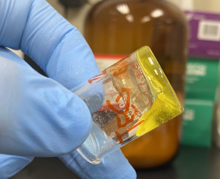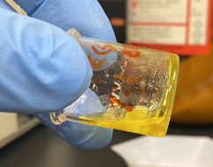
Figure 9. Visual showcase of the different viscosities when using 2:1 ratio of DMA-EMA:CQ (left) and 1:2 ratio of DMA-EMA:CQ (right).

Light Specificity
When viewing the effect of light specificity, it was found that the batch under red light remained a liquid while the batch under the blue light had solidified after the predetermined cure time. This reaction, or lack there of, was further confirmed using Fourier Transform Infrared Spectroscopy or FTIR (see Figures 10 and 11). The peak that helps identify the polymer reaction proceeding, would be the C=C peak. When the polymerization reaction happens, the radical reaction causes the loss of the C=C to form a connection. In the red-light IR spectrum, we can see a strong peak around 1637cm⁻¹ while in the blue light IR spectrum, the 1637cm⁻¹ peak is, relatively, much weaker. While it still being there means some molecules are left unreacted, it being much weaker shows that majority of the molecules have reacted to form the polymer chain.

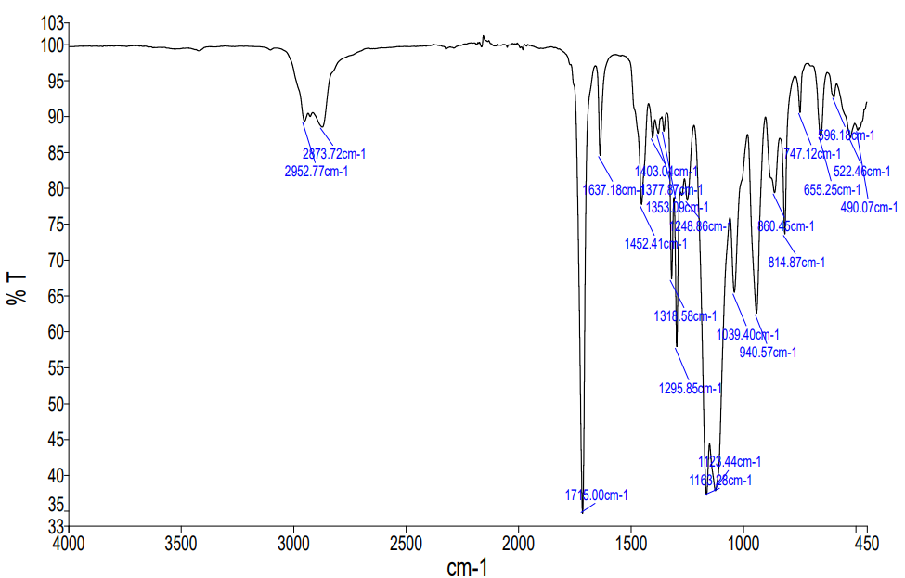
Figure 10. FTIR spectrum of TEG-DMA+CQ+DMA-EMA under blue light for 5 minutes.
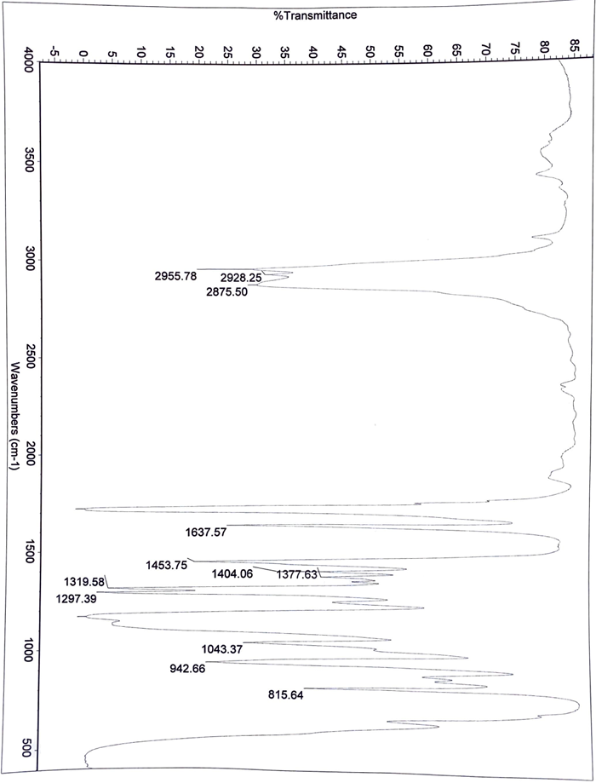
Figure 11. FTIR spectrum of TEG-DMA+CQ+DMA-EMA under red light for 5 minutes.

Other DMAs
UDMA was much harder to work with and as such, TEG-DMA was primarily used. This, however, does not mean UDMA did not work. UDMA was simply much more viscous on its own when compared to TEG-DMA. While TEG-DMA was a liquid that seemed to have a slight thickness to it, UDMA was much more like honey; it was very sticky and did not flow well. That being said, a test was still performed with UDMA. This test did not use filler as UDMA alone was thick enough to hold its shape. Once cured, an IR spectrum was obtained. This mixture showed similarities to the 45% filler mixture with TEG-DMA. Both the trial 1 of TEG-DMA and UDMA mixtures were yellow in colour, had a honey-like thickness before curing and when cured, solidified to be hard to the touch. In the before and after curing IR for UDMA (Figures 12 and 13, respectively), we can see that the peaks around 3300 cm⁻¹ and ~1640 cm⁻¹ both decrease once cured. These two peaks are most likely the N-H and C=C peaks respectively. The drop in peak absorbance for both is most likely proof of the polymerization reaction happening. When forming polymers, as discussed before, the C=C is lost in the radical reaction. It could also be theorized that the N-H bonds are involved in H-bonding/forming the crosslinks when polymerized, therefore, we see a drop in absorbance intensity.

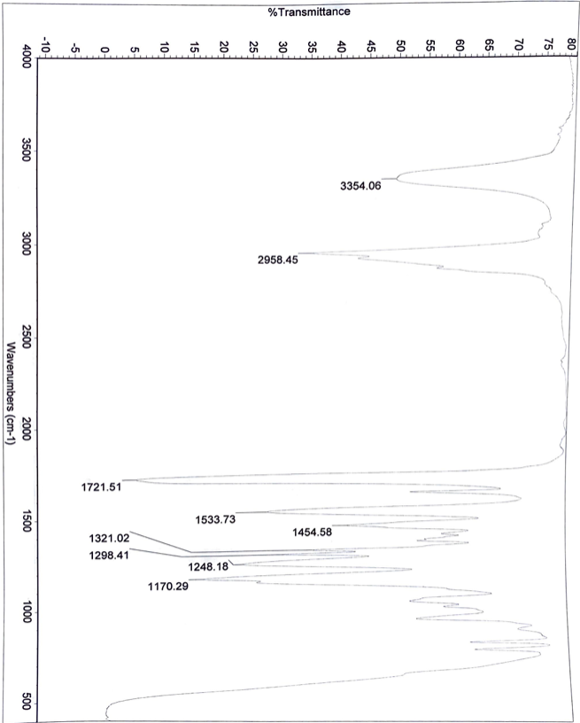
1637
Figure 12. UDMA+CQ+DMA-EMA IR spectrum before blue-light cure.
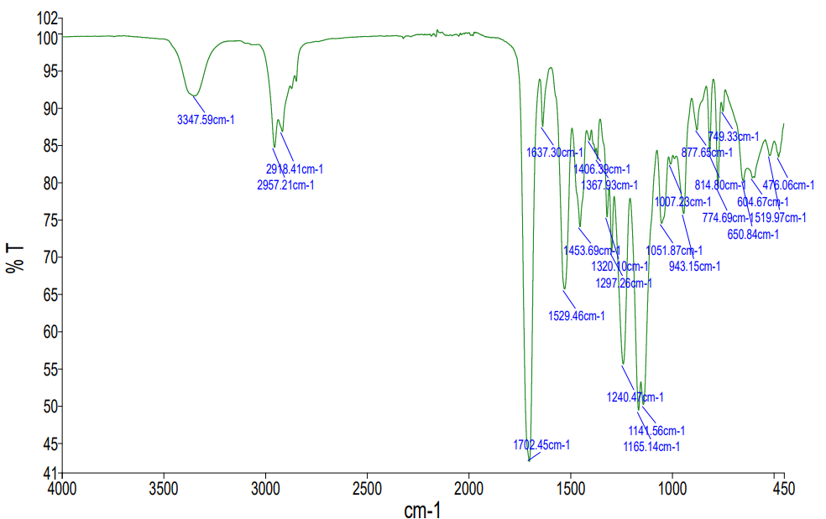
Figure 13. UDMA+CQ+DMA-EMA IR spectra after 5-minute blue-light cure.

Discussion (future work/improvements)

After running multiple tests and documenting the data, it can be said that the experiment showed promise and a successful procedure was developed. However, there is more to be found and documented. One of the papers used for this research had discussed mixing TEG-DMA and Bis-GMA in a 1:1 ratio.⁵ It would be interesting to attempt to mix the UDMA and TEG-DMA and see how that affects things like colour, cure time, etc. It is worthwhile to note that UDMA was thick enough to not need any filler and when cured remained hard like TEG-DMA with filler. However, UDMA did not dissolve the CQ as well as TEG-DMA did. Perhaps mixing the two would find a suitable middle ground.
One disappointment in the research was that tests using D₃MA were not able to be done. When received, the D₃MA was solidified and could not be scooped. Whether it was frozen in some sense or simply reacted somehow during transport is left unknown. Perhaps it could be ground up and mixed with TEG-DMA to dissolve it and then used.
Additionally, optimizing and finalizing the procedure for making the cured product should be done so that more ways of testing characteristics besides simple IR and colour could be done. If possible, involving the physics department would be nice as force testing would be one avenue of interest. To do this a standardized amount, shape, and depth of the sample would be needed so that it could be run on a force gauge equipped with an Ametek Point adapter to identify which DMA (TEG-DMA or UDMA or a mixture) performs best.
Another route of interest would be to see if an experiment could be developed that would start with the building blocks: methacrylate, TEG, etc. and then students would synthesize TEG-DMA, UDMA or other DMAs. From here, they could use their synthesized products to follow along with the procedure made in this experiment. The laboratory for this synthesis could revolve around giving the students an unknown backbone and, through IR and other properties, have the students identify what they started with.

REFERENCES:

- Public health England. https://www.gov.uk/government/publications/oral-health-survey-of-adults-attending-dental-practices-2018#:~:text=27%25%20had%20tooth%20decay,%25%20had%20gingival%20(gum)%20bleeding (accessed 2024-01-17)
- National Institute of Dental and Craniofacial Research. https://www.nidcr.nih.gov/research/data-statistics/dental-caries/adults (accessed 2024-01-15)
- Dental Polymer Lab Pre-Lab. Wentzel Lab. Youtube, February 24, 2019. https://www.youtube.com/watch?v=C_tgPi-DRz4&ab_channel=WentzelLab
- Chu, T.-M.; Platt, J. Original Research Dental Materials Hani Nassar (A). https://doi.org/10.1590/1807-3107BOR-2016.vol30.0066.
- Maciel, D. da S. A.; Caires-Filho, A. B.; Fernandez-Garcia, M.; Anauate-Netto, C.; Alonso, R. C. B. Effect of Camphorquinone Concentration in Physical-Mechanical Properties of Experimental Flowable Resin Composites. BioMed Research International, 2018, e7921247. https://doi.org/10.1155/2018/7921247.

