Dipeptide Derivatives Synthesis Project
Mason Swanton
Date of Experiment: October 20th, 2022
Date Handed in: December 12th, 2022
Unknown #1

Abstract:
Over the course of two experiments, a dipeptide derivative was synthesized. The initial reaction was a condensation reaction in Schotten-Bauman (S-B) conditions.¹ It was started with an unknown acyl chloride and glycine. This reaction led to an unknown amide derivative which was later identified as m-toluoylamino acetic acid. In the second part of this large experiment, our unknown amide derivative was used with the action DCC and methyl glycinate HCl to make our dipeptide derivative methyl 2-[[2-[(3-methylbenzoyl)amino]-acetyl]amino]acetate.¹ NMR for experiment 3 and IR for both was used to help identify our products along with an experimental melting point found to be 140.5-142.3°C and 93.7-94.7°C for experiments 3 and 4 respectively.² The experiment procedures yielded 2.4681g and percent yield of 31.95% for experiment 3 and a yield of .102g percent yield of 4.01% for experiment 4.

Introduction:
This report will detail the results of two experiments and what occurred within those experiments. This will cover the reaction, what was used, and how it was carried out. Our two sets of products were determined via melting point and IR, while NMR was used alongside melting point and IR for experiment 3.
In Experiment 3 our conditions were Schotten-Bauman (S-B) conditions which are basic conditions at 5°C.
IN experiment 4, DCC and TEA were used as well as the reaction happening at 0°C
In the second experiment, DCC is used to initiate a reaction. The reason for this is because DCC is a good coupling reagent.³ A benefit to using DCC is that, since it is insoluble in water and therefore is carried out in organic solvent, it does not have any hydrolysis problem.³ DCC benefits our experiment further as when it is used with excess carboxylate and no presence of the amide, it will for a symmetrical anhydride² which can then be reacted to form an amide bond.

Reaction Scheme:
Figure 1. Reaction Scheme for experiment 3

Figure 2. Reaction scheme for experiment 4

Reaction Mechanism:
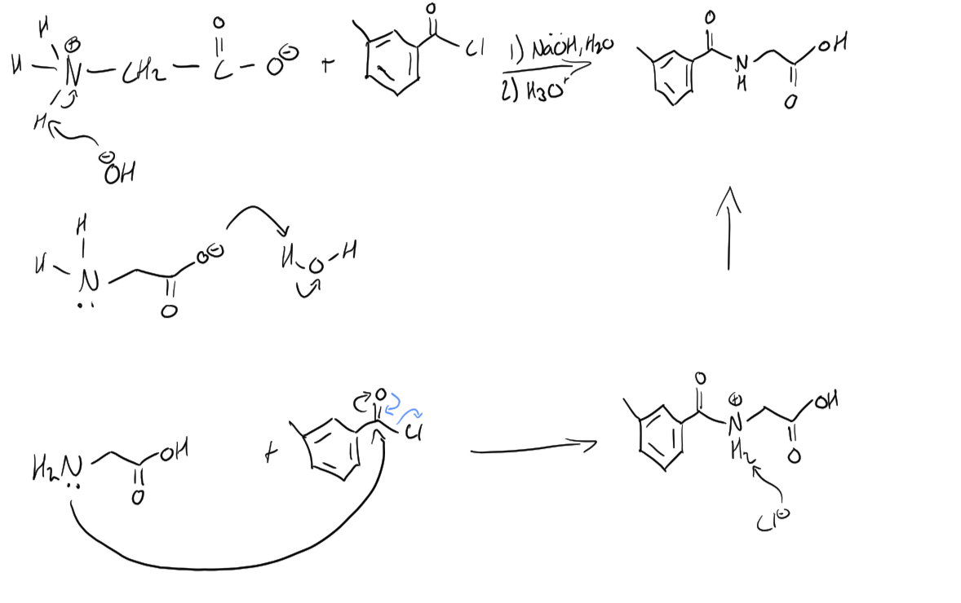
Figure 3. Mechanism for experiment 3

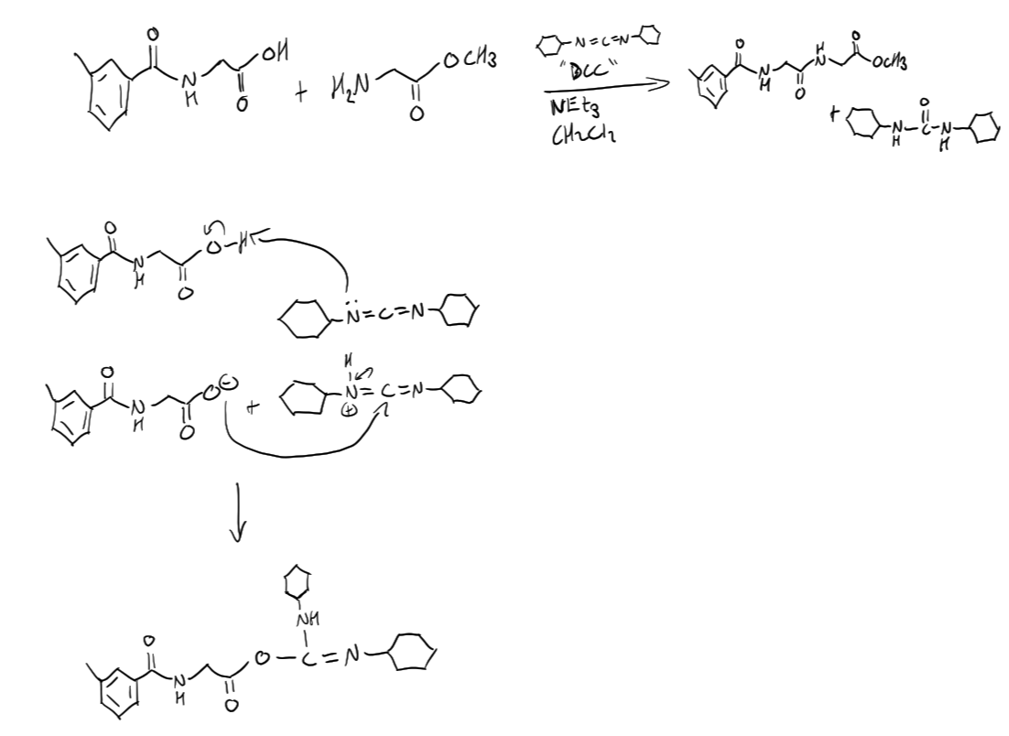
Figure 4. Mechanism for experiment 4 part 1
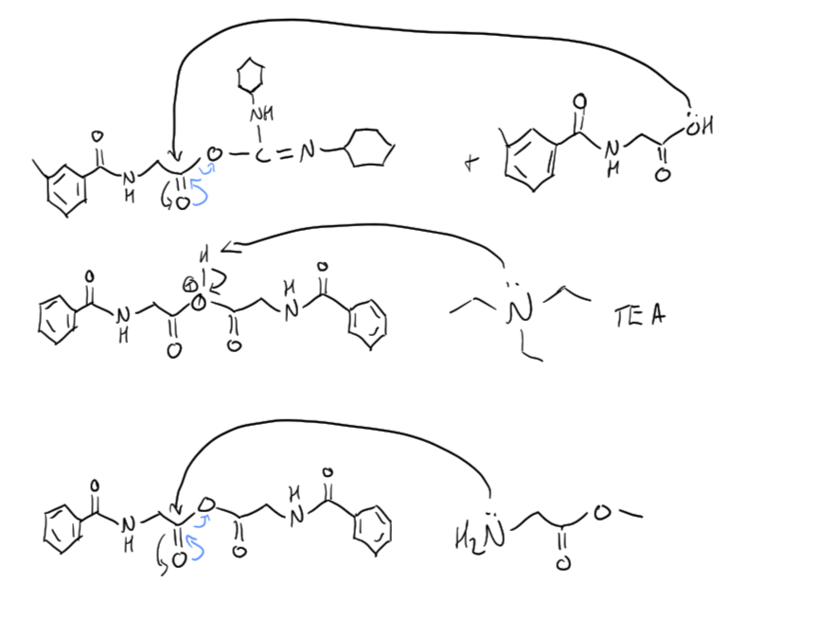
Figure 5. Experiment 4 mechanism part 2
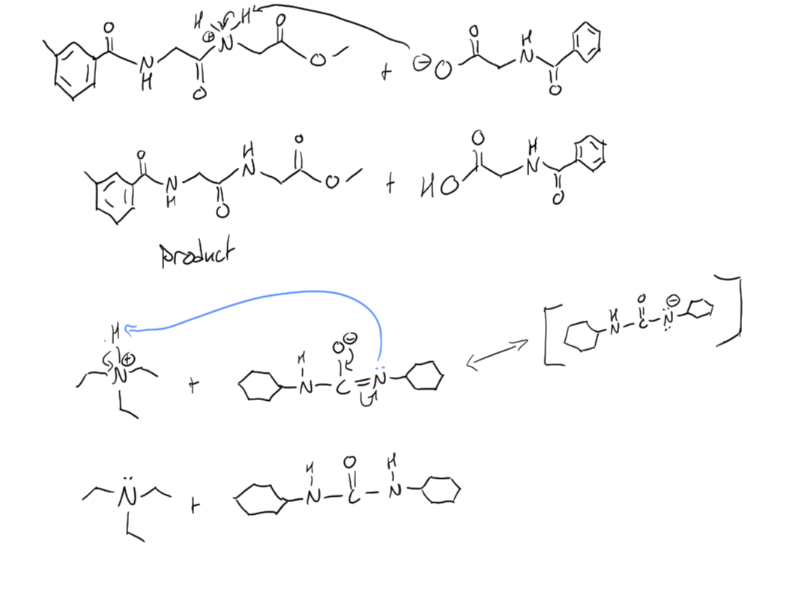
Figure 6. Experiment 4 mechanism part 3

Experimental:
This experiment was carried out following both lab manuals.¹
In experiment 3 the unknown sample was unknown 1 and appeared clear with a yellow tint. After around 3 additions of our unknown and NaOH small white specs begin to appear. When separating the two layers appeared yellow tinted, however the aqueous layer was slightly cloudier. After the two rinses the ether layer appeared clear while the aqueous appeared cloudy until the final rinses. When adding HCl to the product, the product gradually changed into a white, glob-like, mess. Final crude product appeared as small white granules.
Experiment 4 part 1: In experiment 4 the mixture in the 100 ml RBF appeared clear while the addition funnel mixture appeared clear/yellow. After dropwise addition the mixture in the RBF is now cloudy white. Adding acetic acid seemed to make the mixture slightly less liquid like yet the color remained cloudy white
Part 2: After DCU is removed by a suction filtration, a white powder is left while the filtrate is cloudy yellow. After washing, the product remains partly cloudy yellow and our drying agent, anhydrous sodium sulfate, is added. After a week has passed, the drying agent is removed via gravity filtration and the filtered mixture appears clear and amber in color. The product was then rotary evaporated leaving behind a clear amber oil.
Part 3: As the crude product was dissolved and mixed with ethanol and Pet ether, it became more pale yellow and began for form into a paste. This was then suction filtrated leaving our product which was a white powder.

Table 1. Table of reagents used throughout both experiments
Chemical Name and Formula | MW (g/mol) | Mass (g) or  Volume (mL) | # of moles | Mole Ratio | Physical Data²
Sodium Hydroxide  NaOH | 39.997 | 22mL |  |  | MP = 323°C  BP = 1388°C  D = 2.13g/mL
Glycine  C₂H₅NO₂ | 75.067 | 3.0010g |  | 1 | MP = 290°C dec  BP = /  D = 1.607g/mL
Ethyl Acetate  C₄H₈O₂ | 88.106 |  |  |  | MP = -83.8°C  BP = 77.1°C  D = 0.9006g/mL
Ether  C₄H₁₀O | 74.121 | 10mL x 4 |  |  | MP = -116.23°C  BP = 34.45°C  D = 0.7135g/mL
Hydrochloric acid  HCl | 36.461 | 10mL |  | 1 | MP = -114.17°C  BP = -85°C  D = 1.187g/mL
m-Toluoyl chloride | 154.59 |  |  |  | MP = -23°C  BP = 219.5°C  D = 1.0265g/mL
DCC  C₁₃H₂₂N₂ | 206.33 | 10mL |  |  | MP = 34.5°C  BP = 122°C (155°C @ 11mmHg)  D = 1.32g/mL
Methylglycinate  Hydrochloride  C₃H₇NO₂.HCl | 125.56 | ~1.2g |  |  | MP = 175°C dec  BP = /  D = /
Anhydrous dichloromethane  CH₂Cl₂ | 84.933 | ~40mL |  |  | MP = -94.91°C  BP = 39.81°C  D = 1.3232g/mL
Triethylamine  C₆H₁₅N | 101.190 | 1.5mL |  |  | MP = -114.7°C  BP = 88.8°C  D = 0.7275g/mL
Acetic acid  C₂H₄O₂ | 60.052 |  |  |  | MP = 17°C  BP = 117.9°C  D = 1.01510g/mL
DCU  C₁₃H₂₄N₂O | 224.342 |  |  |  | MP = 233.8°C  BP = 408°C  D = 1.02g/mL
Sodium bicarbonate  NaHCO₃ | 84.007 | ~15mL |  |  | MP = 527°C  BP = /  D = 2.20g/mL
Sodium sulphate  Na₂SO₄ | 142.043 | ~15mL |  |  | MP = 884°C  BP = /  D = 2.7g/mL
Ethanol  C₂H₆O | 46.068 | 5mL |  |  | MP = -114.14°C  BP = 78.24°C  D = 0.7893g/mL
Petroleum ether  C₆H₁₄ | 86.178 | 10mL |  |  | MP = /  BP = 35-60°C  D = ~0.6g/mL
(m-toluoylamino)acetic acid | 193.20 | 2.0025g |  |  | MP = 138-140°C  BP ~ 329.41°C  D ~ 1.2307g/mL

Results:

Table 2. Table of products synthesized over the two labs (First product is from exp 3, while second is from exp 4)
Product Synthesized | Appearance | Melting Point (literature) | Melting Point (experimental) | Theoretical Yield | Actual Yield | % Yield
(m-toluoylamino)acetic acid | Product appears as small, fine, white granules | 138-140°C | 140.5-142.3°C | 7.724g | 2.4681g | 31.95%
Methyl 2-[[2-[(3-methylbenzoyl)amino]-acetyl]amino]acetate | Product appears white, larger, powder | unknown | 93.7-94.7°C | 2.5424g | 0.102g | 4.01%

Sample calculations:

%Yield for experiment 4:
(Actual Yield/Theoretical yield) x 100
= (0.102g/2.5262g) x 100
= 4.04%

Limiting reagent for experiment 4:
We know the ratio is 1:1 for methylglycinate*HCl and m-toluoylamino acetic acid meaning 1 mole of glycinate reacts with one mole of our experiment 3 product.

m-toluoylamino acetic acid mol = (mass used)/(molecular weight)
= 2.0025g/193.2g/mol
= 0.01036mol

methylglycinate*HCl mol = (mass used)/(molecular weight)
= 1.208g/125.56g/mol
= 0.00962mol

Therefore, methylglycinate*HCl is the limiting reagent.

Theoretical yield for experiment 4 (use the limiting reagent mol)
(0.00962mol)(264.28g/mol)
= 2.5424g
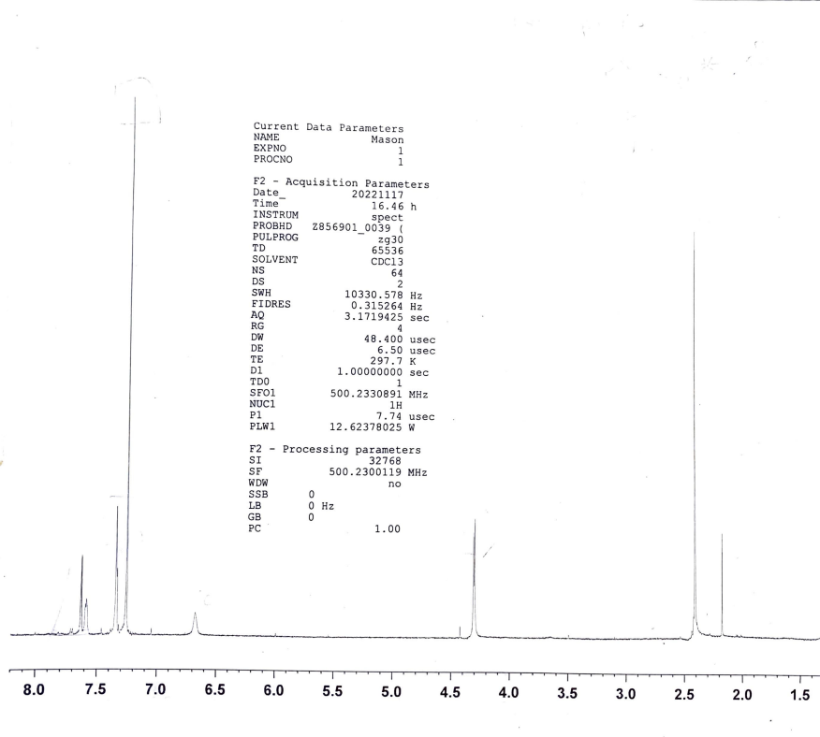

CH3Cl
Figure 7. H-NMR of our experiment 3 product

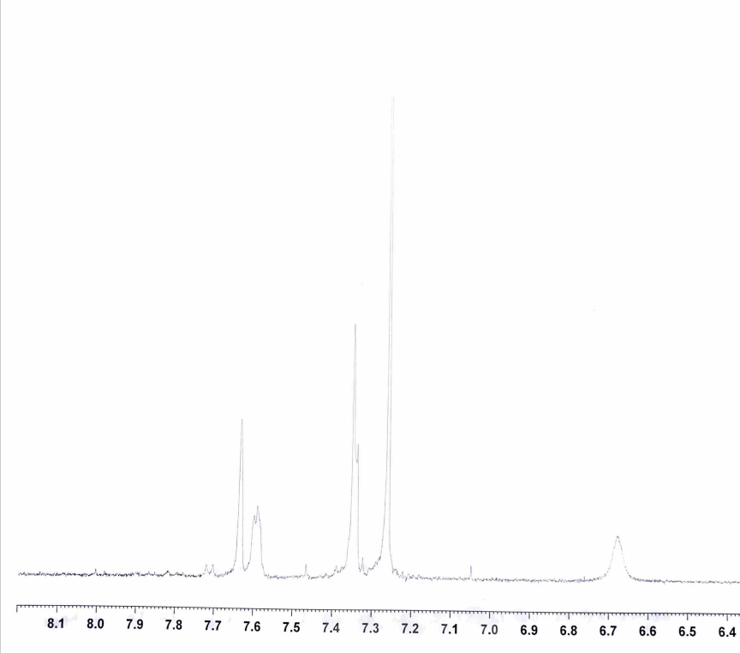
Figure 8. Zoomed in photo of most downfield NMR peaks

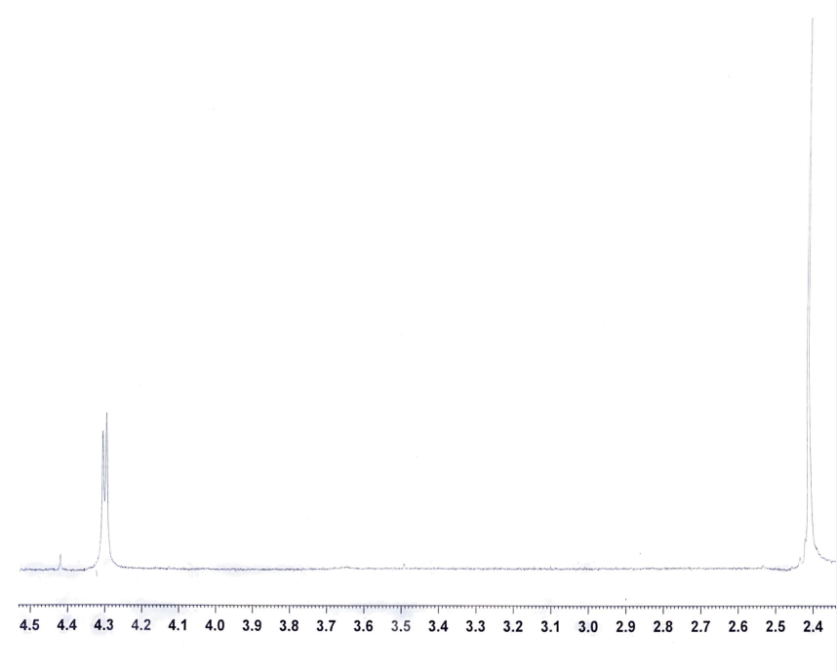
Figure 9. Zoomed in photo of prominent upfield peaks

Table 3. Legend of NMR peaks
H or H’s Making the Peak | Peak Type | Shift | Integration
 | Doublet of doublets  (Although peak isn’t well defined) | 7.35ppm | 1
 | Doublet  (Again, peak is an undefined peak, although based on the molecule it would be a doublet) | 7.59ppm | 1
 | Singlet | 7.65ppm | 1
 | Doublet | 4.30ppm | 2
 | Singlet | 2.40ppm | 3
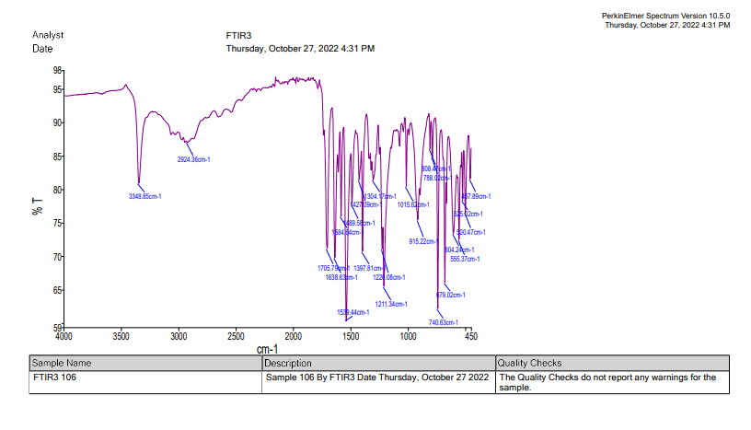
C=C
C-N bond
C-H
C=O bond
N-H bond
O-H bond
Figure 10. IR spectrum of product from experiment 3

Table 4. Experiment 3 IR graph important values
Experimental Frequency  (cm⁻¹) | Appearance | Group
3348.85 | Medium, narrow | Secondary amine N-H
2924.36 | Medium, broad | Carboxylic acid O-H
Around 2900 | Small, narrow | C-H bond alkane
1705.79/1638.63 | Strong, narrow | Carboxylic acid C=O
1539.44 | Strong, narrow | C=C alkene
1211.34/1226.08 | Strong, narrow | Amine C-N

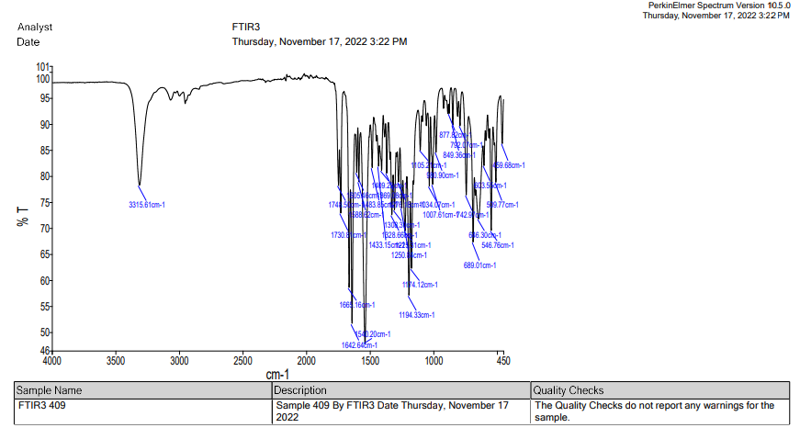
C-H
C-N
C=O
C=C
N-H
Figure 11. Experiment 4 IR graph

Table 5. Experiment 4 IR graph important values
Experimental Frequency  (cm⁻¹) | Appearance | Group
3315.61 | Medium, narrow | Secondary amine N-H
Around 2900 | Small, narrow | C-H bond alkane
1748.50/1730.81 | Medium narrow | C=O bonds
1665.16/1642.64/1540.2 | Strong, narrow | C=C alkene
1194.33/1174.12 | Strong, narrow | Amine C-N

Note: Both IR graphs have lots of peaks within a small area that can be hard to discern what is what. However, the main difference to pick out is that in experiment 3 there is an OH stretch present in the IR, while in experiment 4 there is no longer an OH stretch.

Discussion:
For experiment 3 it was found, using NMR, that the product was m-toluoylamino acetic acid, also known as 3-methylhippuric acid. The literature melting point for m-toluoylamino acetic acid is 138-140°C which further confirms that product as our experimental melting point was found to be 140.5-142.3°C.²
When comparing the IR graph to what the expected product is to be we can also confirm the correct product was synthesized as we see a N-H peak representing the newly formed bond only found in the product. We can also see some C-H, C=O, and C-C bonds which is to be expected for the structure, although not too helpful as those are common bonds.
Our NMR confirms that…

Just kidding Heidi, I didn’t forget this time. Our NMR confirms that the methyl is on the meta position of the benzene through the process of elimination. While the NMR is quite messy, there are some clear main take aways to determine our product. Firstly, no clean doublet peaks, reminiscent of para position, are seen. This means one option is ruled out. Second, there is a singlet seen around 7.65. A singlet is only possible when a H has no neighbours. That means that it can’t be ortho, so the only option left is meta. We can then determine that it is a CH3 and not OCH3 because there is a strong singlet peak near 2.5ppm. If it was OCH3 the peak would be more downfield as it would be near an EN atom.
The mechanism is experiment 3 involves Schotten-Bauman (S-B) reaction conditions to form our amide with an addition/elimination on the m-toluoyl chloride. The basic condition prevents any unwanted protonation (See fig 3 for mechanism). The theoretical yield of experiment 3 was 7.724g, while the actual yield was 2.4681g leading to a percent yield of 31.95% which is quite low. We can expect that some product was lost from the large number of transfers as well as to becoming an amine salt possibly. However, the main loss would most likely come from the recrystallization process which was seeming to have some issues with most experiments, not just one. It would be wise to look into a way to fix this recrystallization issue as that should result in a bump to the yield.

Experiment 4: In experiment 4, the reaction was kept at a lower temperature to avoid N-acylurea formation and with TEA to avoid any unwanted protonation (see fig 4-6 for mechanism). The mechanism was initiated by DCC removing the OH hydrogen and then getting attacked by the now O⁻. It was concluded that the product made was Methyl 2-[[2-[(3-methylbenzoyl)amino]-acetyl]amino]acetate. This was determined mainly from IR, but a melting point was taken despite there being no good source to compare to. The IR graph confirms our product as there is no longer an OH stretch seen. This makes sense as the terminal carboxyl group does not have an OH but instead an OCH₃. The yield for experiment 4 was 0.102g with a percent yield of 4.01% and an experimental melting point 93.7 – 94.7°C. This yield is quite poor meaning we should search for a far better way to synthesize this product. It is possible that this poor yield was from an incorrect addition process in the addition funnel. I would also suspect the low yield to be a result of the separation process but am not fully sure on what may be a way to fix that. The main lose is most likely from the filtration process. Finding a better filtration process instead of gravity filtration may increase yield.

Cyclic dipeptides, or diketopiperazines (DKP), are found abundantly in nature and are very structurally and bio-functionally diverse, due to their extra rigid conformation, high resistance to enzyme degradation, high cell permeability, and their ability to bind to targets with high affinity. Due to these benefits, lots of new research, especially now, is surrounding these molecules.⁴ Some research has even gone into DKPs effects on cancer, and it was found that proline based DKPs were useful in the treatment of cancer and for anticancer therapy.⁴ This type of research is very intriguing and can have a wide array of uses. DKPs, especially proline based, have a huge potential for bioengineering and more as we can pick out desirable features through specific reactions of amino acids and their stereochemistry. Furthermore, DKPs are very important in what is known as DKP scaffold. A scaffold is useful in medicinal chemistry and drug design to create cores of bio-active substances.⁴ The scaffold of DKPs is made with the removal of the R-groups leaving behind the main ring system.⁴ This ring system can then be altered by adding functional groups to create drug delivery systems, therapeutic drugs, and more.⁴ The research into these DKPs I by far some of the most intriguing research recently as it has a nearly endless amount of possibilities for the medical world.

Conclusion:
Throughout both experiment 3 & 4, our products were consistent with their literature values, meaning the synthesis of our dipeptide derivative was a success. M-toluoylamino acetic acid was synthesized in experiment 3 and methyl 2-[[2-[(3-methylbenzoyl)amino]-acetyl]amino]acetate was synthesized in experiment 4. In experiment 3, our product was white and fine granules with a melting point of 140.5-142.3°C and a yield of 2.4681g and percent yield of 31.95%. While experiment 4 yielded a white powder-like product with a yield of .102g percent yield of 4.01% and a melting point of 93.7 – 94.7°C.

References:
- Huttunen-Hennelly, H. Organic Chemistry 3240 Laboratory Manual; Thompson Rivers University: Kamloops, B.C, 2022
- Physical Constants of Organic Compounds. In CRC Handbook of Chemistry and Physics. 102nd edition.; [Online]; Rumble, J. R., Ed; CRC Press: Boca Raton, FL, 20221; pa; https://hbcp.chemnetbase.com (accessed Dec 11, 2022)
- Hermanson, T.G., Zero-length crosslinkers, 2013. ScienceDirect Topics, https://www.sciencedirect.com/science/article/pii/B9780123822390000042 (accessed Dec 11, 2022).
- Bojarska, J.; Mieczkowski, A.; Ziora, Z. M.; et al., Cyclic dipeptides: The biological and structural landscape with special focus on the anti-cancer proline-based scaffold. https://www.ncbi.nlm.nih.gov/pmc/articles/PMC8533947/ (accessed Dec 11, 2022).

Questions:

Experiment 3
- Normally, if time permitted, with any new compound that has not been reported in the literature we would do at least two recrystallizations (or possibly more) and establish a melting point after each recrystallization. At what point can we stop doing recrystallizations and judge that our compound is very close to being 100% pure?

The recrystallizations could be stopped once we reached a consistent melting point that does not vary with each new test. This is because we know that impurities depress melting points and therefore, it is very likely that the melting point we took has impurities that has lowered it. Therefore, it would be beneficial to continue to recrystallize and test until the melting point remain in a small, consistent, range. Only then could we be more sure that it is our pure product.

- Why is the sodium hydroxide added alternately with the acid chloride rather than in one portion at the very beginning of the procedure?
NaOH is added alternately with the acid chloride to ensure that the reaction stayed basic and at 5°C. If we had added all the base at once and then the acid, we would risk raising the pH which would cause problems for our reaction. We need to keep the reaction in base to overcome the byproduct of HCl by adding alternately. If we didn’t keep basic conditions, The HCl would protonate the remaining amide and we would lose around 50% of our product to amine salt.

- Which do you expect to be more reactive with an amine, an acid chloride like compound 8 or a carbonyl chloride like compound 3? Explain your answer using molecular structures.
We would expect an acid chloride, like compound 8, to be less reactive with the amine. This is because in the carbonyl chloride, like compound 3, there is an oxygen atom that will be pulling electron density away from the carbon through inductive effects. This will make the carbon more partially positive and thus more likely to be attacked by the Nitrogen electrons

- What additional characterization (i.e. besides those listed at the end of the experimental procedure) would you obtain if you had made the amide of any natural amino acid other than glycine?
If we used an amino acid other than glycine, we could have then tested via chirality as glycine is the only amino acid to not have an R-chain, but instead a hydrogen. If we could test chirality, we could then discern the molecule we synthesized into D or L configuration depending on which way it rotated the light in a polarimeter.

Experiment 4
- Note 2 states that “the reaction temperature is kept moderate to minimize N-acylurea formation.” Suggest a mechanism for the formation of such a by-product. (HINT: consider the intermediates in the mechanism of the desired reaction).
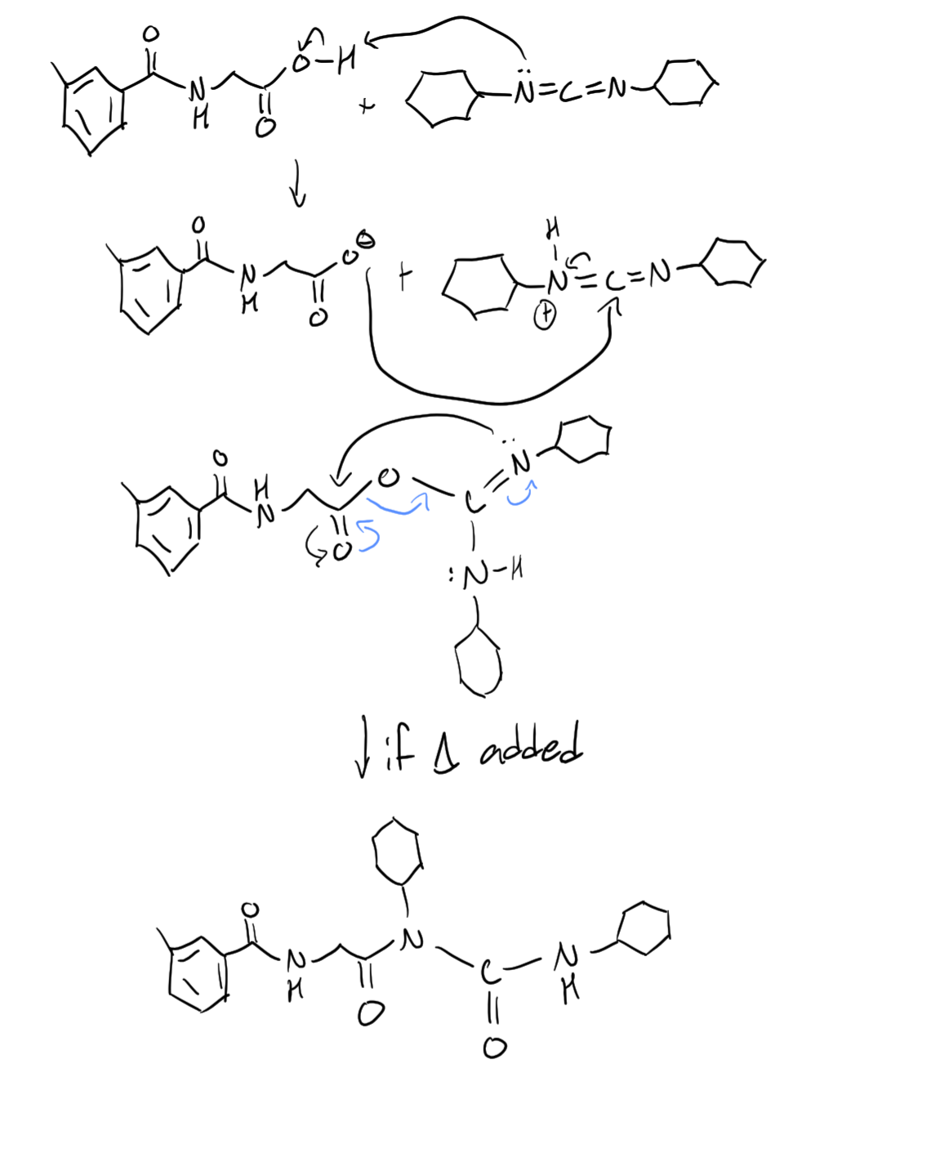
Figure 12. Proposed mechanism of heat was present

- Why is one equivalent of triethylamine added to the reaction mixture?
One equivalent of triethylamine is added to prevent HCl from protonating DCC, which would ruin the reaction, and any of the other reactants. It was also used as a base to strip away a hydrogen, and then donate that hydrogen to DCU thus completing the reaction and regenerating our starting materials.

Happy holidays and thanks for teaching the labs!

