
HAZARD OVERVIEW AND SAFTEY RECOMMENDATIONS REGARDING THE JULY 23RD, 2025 OXYBENZONE SPILL

November 28, 2025
Mason Swanton T00246877

Table of Contents
Abstract 2
Introduction 3
Main Body 4
Chemical Properties 4
Structure 4
Physical and Chemical Properties 4
Environmental Partition Coefficients 5
Method of detection 5
Uses and Sources 5
Environmental 6
Entry Routes 6
Impacts 6
Distribution into Lake 8
Regulations 9
Predicted Concentration and Impact Assessment 10
Conclusion 11
References 12
Appendix 14

Abstract
This report, by the BC Ministry of Environment, will detail the evaluation regarding the recent train car spill in North Okanagan Lake, BC. The high-pressure tank car derailed at approximately 9:40a.m. spilling benzophenone-3 (oxybenzone) into the lake. Partition coefficients from literature sources predicted that the chemical would likely partition into the soil or organic material within the lake and remain there. This means that the drinking water will be unaffected. However, given the chance of bioaccumulation, from its presence in soil or organic matter, it is advised that, in the abundance of caution, fishing within that lake be restricted for a year and pending further testing. Furthermore, in the best interest of the public, the beaches will be closed off until the contaminated soil in the lake is dredged and testing for oxybenzone reads normal levels once again.

Introduction
Oxybenzone is a widely used chemical in personal care products due to its UV protection and stability. At around 9:40a.m. on July 23rd, 2025, a high-pressure tank car carrying 120,000 L of oxybenzone at a concentration of 3.7 mg/L was derailed when a clash between local, unknown, criminals resulted in part of the track being destroyed. The tank car proceeded to launch off the tracks and into the middle of North Okanagan Lake. The tank car sank to the bottom of the lake where the water was seemingly homogenously mixed with the chemicals being carried. North Okanagan Lake is a popular spot for public activities such as fishing, swimming, boating, and more. The lake also provides a drinking water source to the nearby community. While dimictic, the lake is currently not experiencing overturn and has three distinct stratified layers. Oxybenzone has been found to be an endocrine disruptor among other hazards, and because of this, the team at WSCAC (Water Spill and Contamination Assessment Centre) has been tasked with identifying any possible risks to those who use the lake, both aquatic and public.

Main Body

Chemical Properties

Structure
Benzophenone-3 or Oxybenzone are the most common names for the personal care product (PCP) that was spilled into Okanogan Lake in North Okanogan. The IUPAC name for this chemical is (2-Hydroxy-4-methoxyphenyl)-phenylmethanon¹ and the structure can be seen in Figure 1.
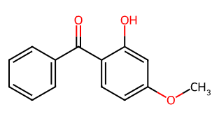
Figure 1. Structure of Oxybenzone¹
This chemical consists of polar groups like the ketone, and alcohol, as well as nonpolar groups like the ether and benzene rings.

Physical and Chemical Properties
Table 1. Physical and Chemical properties of the PCP Oxybenzone
Average mass¹ | 228.24 g/mol
Density¹ | 1.3 g/mL
Melting Point² | 65.5°C
Boiling Point¹ | 346.3°C
Vapor Pressure¹ | 0.0±0.9 mmHg at 25°C
Water Solubility² | 3.7 mg/L at 25 °C
K_{OC} (pH 7.4)¹ | 1818.30
pKa² | 7.1
Henry's Law Constant² | 1.50E-08 atm-m³/mol

Environmental Partition Coefficients

Table 2. Partition Coefficients of Oxybenzone
Air-Water Partition Coefficient | Kaw | Not commonly cited
Octanol-Water Partition Coefficient | Log Kow | 3.79
Soil Adsorption Coefficient | Koc (pH 7.4)¹ | 1818.3
Bioconcentration Factor | BCF (pH 7.4)¹ | 309.75

Method of detection
Water Samples | LC-Tandem-MS | LOD of 0.5 ng/L¹²
Water Samples | LC-MS/MS | LOD of 0.15 ng¹⁴
Sand Samples | UHPLC-(ESI)-Orbitrap MS analysis | LOD of 0.01-0.06 ng/g¹³
Fish | LC-MS/MS | LOD of 0.03 ng¹⁴

Uses and Sources
Oxybenzone is a naturally occurring and man-made chemical that is used to absorb ultraviolet (UV) radiation.⁴ This makes it a widely used chemical in personal care products (PCPs) like sunscreens, lotions, lip balms, and more. Oxybenzone is also used in products to prevent degradation from UV light like plastics, paints, or inks.

Environmental

Entry Routes
Oxybenzone enters the environment through two main ways. The first is from human activity. Despite oxybenzone having low water solubility, when people use lotions, sunscreens, etc. and then come into contact with water, some of the oxybenzone will find its way into the water.⁶ The other source of entry is from inefficient degradation in wastewater treatment plants.⁶ Given that Okanagan Lake has many beaches, paired with oxybenzone’s insufficient biodegradability, it can be surmised that oxybenzone has entered the lake not only from the crash, but also slowly over time from public use.

Impacts
Many studies have been done regarding the toxicity of oxybenzone. One of the more concerning takeaways is that oxybenzone has been found to be an endocrine disruptor. Below, in table 3, are just some of the results from a study that summarizes the EC₅₀ (the dose leading to have the maximal response) of BP-3 (oxybenzone) on different areas from many in vivo experiments.
Table 3. summary of EC₅₀ for various in vivo targets⁷
Target | EC₅₀ ( µM)
Estrogen receptor (α and β) | > 1
Androgen Receptor | 2 - 10
Thyroid hormone regulatory genes (GH3) | 10
Oocyte and blastocyst stage (mouse) | 0.5
Cytotoxicity | > 10

In addition to the in vivo testing, in vitro testing has shown that benzophenone-3 can impact both male and female reproduction via sperm motility and oocyte maturation respectively⁷. BP-1, a metabolite of BP-3 (oxybenzone), is more potent, even at concentrations as low as 1 µM, which is around the mean peak concentrations found in human plasma after sunscreen use.⁷
In aquatic life, oxybenzone was shown to have similar effects. Male fish were seen to have a decrease in courtship and aggression affecting their mating and therefore reproduction, as well as a loss of secondary sexual traits or inhibition of spermatogenesis. While the female fish saw a reduced number of eggs being spawned.
It is worthwhile to mention that the average concentration found in urine in 2018 to 2019 was 16 µg/L⁴, well below the lowest EC₅₀ of 0.114 mg/L for oocytes in mice.

Distribution into Lake
Oxybenzone has a half-life range of 0.5 to 4038.21 days in natural water⁶ but a reported range of 8.7-13.5 days in soil.¹¹ The figure below shows just a few of the possible chemicals oxybenzone can degrade into.
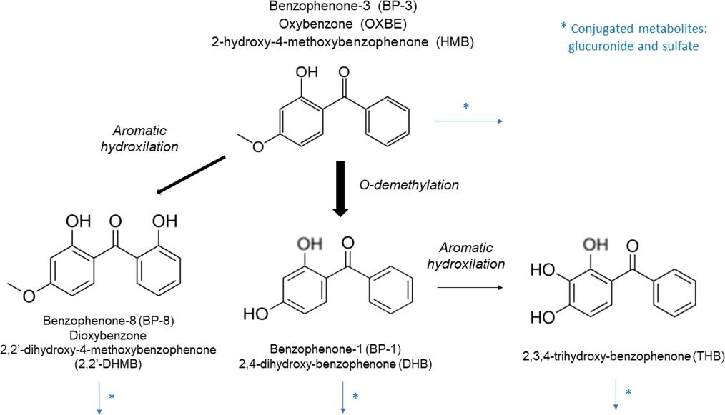
Figure 2. Some of the primary products from the breakdown of Oxybenzone⁷
Oxybenzone has extremely low water solubility, backed up by a high Log K_{OW} of 3.79 which means it is not likely to remain, and therefore spread, in the lake by natural turnover or water movement. However, oxybenzone has a high K_{OC} at 1818.3 meaning it will readily adsorb to the soil or organic matter. This poses a specific problem with the aquatic life in the lake. While the log BCF of oxybenzone is small (2.5), meaning it is unlikely to bioconcentrate, it does have the potential to bioaccumulate in invertebrates and fish as any detritovore or bottom feeder will likely consume oxybenzone allowing it to travel up the food chain. Furthermore, some studies have suggested that the byproducts of oxybenzone (BP-3) like BP-1, BP-2, and BP-8 have a higher toxicity and likelihood of bioaccumulation.⁶

Table 4. Lake Information³
Lake: | Okanagan Lake
EMS ID: | 0500730
Region: | Okanagan
Latitude: | 50.0899 N
Longitude: | -119.4783 W
Site Depth: | 178 m
Maximum Depth: | 232 m
Elevation: | 342 m
Surface Area: | 350.08 sq km
Volume:¹⁰ | 24.644 km³
pH:⁵ | 8.1

This lake experiences dimictic overturn lake and is home to many beaches open to the public as well as a source for fishing and for drinking water provided to the local community.

Regulations

Table 5. Oxybenzone regulations for different products in certain countries
Product | Canada⁸ | United States of America⁸ | European Union⁸
Sunscreen | Up to 6% | 6% but under review | Maximum of 6%
Face cream | - | - | Maximum of 6%
Body creams | - | - | Maximum 2.2%
Cosmetics  (to prevent deterioration) | - | - | 0.5%

Regulations around oxybenzone, in Canada, primarily focus on its use in sunscreen. As seen in table 5, oxybenzone can be present in sunscreen up to 6% w/w, but it must have the DIN labelled on the bottle for the consumer. The lack of regulations is a point of interest for not only Canada, but also USA and the EU as there has been recent concerns regarding oxybenzone’s potential hazards like endocrine disruption.¹⁵

Predicted Concentration and Impact Assessment
To prevent any unnecessary exposure, the area nearest the crash, Boyce-Gyro beach in Okanagan Lake, should be immediately closed off to the public for recreational and fishing use. Luckily, the partition coefficients predict oxybenzone will not partition to the air and will prefer soil and organic matter meaning it is likely to settle at the bottom of the lake around the crash site as the lake is not experiencing any overturn and water movement in lake bodies is minimal. While there is currently no good way to remove oxybenzone from the water through water treatment plants, the amount that is suspended in the water and goes into the treatment plant will be negligible or similar to current values found in the lake from other causes. All this to say that the addition of oxybenzone from the crash spill will not cause drinking water contamination thanks to it being nearly insoluble in water. The low BCF suggests that it will not concentrate in the fish already in the lake. However, while it may be unlikely,⁹ the possibility of bioaccumulation from detritovores or bottom feeders roaming the soil, and therefore through the food chain⁶ should lead to a fishing ban being put on the lake until the spill is contained/dealt with and pending testing done on fish throughout the coming years. Lastly, while byproducts like BP-1 are more dangerous, the low concentration of BP-3 should not provide any reason for concern regarding the byproducts. Additionally, promptly dealing with the spill will greatly reduce the likelihood of byproduct formation.

Conclusion
It was determined that the concentration of Oxybenzone (benzophenone-3) present in Okanagan Lake after the train car crash (0.018 ng/L) poses no immediate potential concern to the public and aquatic health of the Kelowna region. That said, some precautions should still be taken. The literature partition coefficients as well as BCF and bioaccumulation suggest that it is possible for the fish found in the lake to accumulate an unknown amount of oxybenzone in their fats. Due to this, the precaution should be made that no fishing will be allowed until the following year and pending further testing of the fish to see if any trace amounts of oxybenzone remain. Additionally, until the spill is contained and a dredge is done of the soil surrounding the spill, recreational activities are prohibited on beaches near the crash site and surrounding area. One suggestion for cleanup would be to look into new research surrounding microbial degradation to mitigate oxybenzone by-products. This could include the Sphingomonas wittichii strain BP14P that has been shown to degrade BP-3 to nearly 95%.⁶ Given all this information, we would recommend that a testing of the water should be done after the cleanup to quantify any lingering concentrations. Pending those results, recreational activities, like swimming or boating, can be opened to the public once again.

References
- ChemSpider. oxybenzone | C14H12O3 | ChemSpider. www.chemspider.com. https://www.chemspider.com/Chemical-Structure.4471.html (accessed Oct 27th, 2025).
- PubChem. 2-Hydroxy-4-methoxybenzophenone Nih.gov. https://pubchem.ncbi.nlm.nih.gov/compound/4632. (accessed Oct 28th, 2025)
- Story Map Series. Arcgis.com. https://governmentofbc.maps.arcgis.com/apps/MapSeries/index.html?appid=a5ffb1bcffad4407b387292f2e55899f (accessed Nov 10th, 2025).
- Canada, H. Oxybenzone in people living in Canada - Canada.ca. Canada.ca. https://www.canada.ca/en/health-canada/services/environmental-workplace-health/reports-publications/environmental-contaminants/human-biomonitoring-resources/oxybenzone-in-people.html?wbdisable=true (accessed Nov 12th, 2025).
- Larratt Aquatic. Okanagan Lake Cleaned-Water Return Outfall Receiving Environment Environmental Impact Study Summary Report. Google.com. https://www.google.com/url?sa=t&rct=j&q=&esrc=s&source=web&cd=&ved=2ahUKEwjGkpq97u-QAxVLOzQIHU17EN0QFnoECBYQAQ&url=https%3A%2F%2Fletstalk.lakecountry.bc.ca%2F18418%2Fwidgets%2F122122%2Fdocuments%2F79569&usg=AOvVaw2_j6j5R0jWGGB-Gw1oioDl&opi=89978449 (accessed Nov 12th, 2025).
- Kotia, N.; Sinha, R.; Aliko, V.; Faggio, C. Benzophenone-3: A Systematic Review on Aquatic Toxicity, Pollution Status, Environmental Risk Assessment, and Treatment Approaches. Science of The Total Environment 2025, 985, 179740. https://doi.org/10.1016/j.scitotenv.2025.179740. (accessed Nov 14th, 2025)
- Mustieles, V.; Balogh, R. K.; Axelstad, M.; Montazeri, P.; Márquez, S.; Vrijheid, M.; Draskau, M. K.; Taxvig, C.; Peinado, F. M.; Berman, T.; Frederiksen, H.; Fernández, M. F.; Marie Vinggaard, A.; Andersson, A.-M. Benzophenone-3: Comprehensive Review of the Toxicological and Human Evidence with Meta-Analysis of Human Biomonitoring Studies. Environment International 2023, 173, 107739. https://doi.org/10.1016/j.envint.2023.107739 (accessed Nov 14th, 2025)
- Oxybenzone - Cosmetics Info. Cosmetics Info. https://www.cosmeticsinfo.org/ingredient/oxybenzone. (accessed Nov 14th, 2025)
- National Academies of Sciences, E.; Division, H. and M.; Studies, D. on E. and L.; Policy, B. on H. S.; Toxicology, B. on E. S. and; Board, O. S.; Usage, C. on E. I. of C. M. S. and P. H. I. of C. in S. Bioaccumulation and Measured Concentrations of UV Filters in Biota. www.ncbi.nlm.nih.gov. https://www.ncbi.nlm.nih.gov/books/NBK587278/ (accessed Nov 16th, 2025).
- ILEC. Okanagan Lake | Okanagan Lake | World Lake Database - ILEC. wldb.ilec.or.jp. https://wldb.ilec.or.jp/Display/html/3452 (accessed Nov 19th, 2025).
- Gautam, K.; Seth, M.; Dwivedi, S.; Jain, V.; Vamadevan, B.; Singh, D.; Roy, S. K.; Downs, C. A.; Anbumani, S. Soil Degradation Kinetics of Oxybenzone (Benzophenone-3) and Toxicopathological Assessment in the Earthworm, Eisenia Fetida. Environmental Research 2022, 213, 113689. https://doi.org/10.1016/j.envres.2022.113689. (accessed Nov 19th, 2025).
- Bratkovics, S.; Sapozhnikova, Y. Determination of Seven Commonly Used Organic UV Filters in Fresh and Saline Waters by Liquid Chromatography-Tandem Mass Spectrometry. Analytical Methods 2011, 3 (12), 2943. https://doi.org/10.1039/c1ay05390f. (accessed Nov 21st, 2025)
- Downs, C. A.; Diaz-Cruz, M. S.; White, W. T.; Rice, M.; Jim, L.; Punihaole, C.; Dant, M.; Gautam, K.; Woodley, C. M.; Walsh, K. O.; Perry, J.; Downs, E. M.; Bishop, L.; Garg, A.; King, K.; Paltin, T.; McKinley, E. B.; Beers, A. I.; Anbumani, S.; Bagshaw, J. Beach Showers as Sources of Contamination for Sunscreen Pollution in Marine Protected Areas and Areas of Intensive Beach Tourism in Hawaii, USA. Journal of Hazardous Materials 2022, 438 (129546), 129546. https://doi.org/10.1016/j.jhazmat.2022.129546. (accessed Nov 21st, 2025)
- Blüthgen, N.; Zucchi, S.; Fent, K. Effects of the UV Filter Benzophenone-3 (Oxybenzone) at Low Concentrations in Zebrafish (Danio Rerio). Toxicology and Applied Pharmacology 2012, 263 (2), 184–194. https://doi.org/10.1016/j.taap.2012.06.008. (accessed Nov 21st, 2022)
- European Union. Regulation - 2022/1176 - EN - EUR-Lex. Europa.eu. https://eur-lex.europa.eu/eli/reg/2022/1176/oj/eng?eliuri=eli%3Areg%3A2022%3A1176%3Aoj&utm_source=chatgpt.com (accessed Nov 28th, 2025).
- Dean, W. E. Characterization of Organic Matter in Lake Sediments from Minnesota and Yellowstone National Park. Antarctica A Keystone in a Changing World 2006. https://doi.org/10.3133/ofr20061053 (accessed Nov 28th, 2025)

Appendix

Okanagan lake has a volume of around 24.6 km³ as per: https://wldb.ilec.or.jp/Display/html/3452

A tank car was carrying around 120,000L of oxybenzone at 3.7mg/L in water.
The lake is 24.6 km³ so 2.46x10¹⁰m³ which then is 2.46x10¹³ L
Assuming homogenous mixing with the lake, C1V1=C2V2 gives:
(3.7 mg/L)(1.2x10⁵ L) = C2(2.46x10¹³ L)
C2 = 1.8x10⁻⁸ mg/L or 0.018 ng/L concentration in the lake water.

Now, given our Koc of 1818.3 (around 7.4pH which is close to the lake’s true pH of around 8), we can calculate how much stays in the water vs moves to organic carbon. Also, we will assume the OC in the soil is about 15% as per reference range of 3-29%.¹⁶
K_{oc} = $\frac{\left[organic carbon\right]}{\left[water\right]}$
K_{D} = $Koc×Foc$
= (1818.3)(0.15)
= 272.75
Doing ICE chart gives:
 | [Water] | [Soil]
I | 3.7 mg/L | 0
C | -x | +x
E | 3.7 mg/L – x | x

So,
$$272.75=\frac{x}{3.7-x}$$
$$1009.175-272.75x=x$$
$$1009.175=273.75x$$
$$x=3.686\frac{mg}{L}$$
This means that 99.63% of the concentration spilled into the lake will partition into the soil or organic matter within the lake.

So, using both calculations, we can assume that all of the oxybenzone spilled into the lake will partition into the soil which gives a concentration of 0.018 ng/L in the soil

